Please indicate in what category you would like to participate in the 2024 RAPDASA-RobMech-PRASA-AMI Conference.

* Academic participation in the Conference with paper taken up in the proceedings of the conference: Extended abstract and full paper required. Choose the track with the best fit for your paper.

A Critical Evaluation of Pure Pursuit, MPC and MPCC: Balancing Simplicity, Performance and Constraints

**X. Kong1*, B Evans2 & C. Fisher3**

* Department of Electrical and Electronic Engineering, University of Stellenbosch, South Africa, [22902716@sun.ac.za](mailto:22902716@sun.ac.za)

2 Department of Electrical and Electronic Engineering, University of Stellenbosch, South Africa, [bdevans@sun.ac.za](mailto:bdevans@sun.ac.za)

3 Department of Electrical and Electronic Engineering, University of Stellenbosch, South Africa, [cfisher@sun.ac.za](mailto:cfisher@sun.ac.za)

**ABSTRACT**

In autonomous racing, different control systems have been developed to ensure fast and precise path tracking. This study compares three common path planning algorithms-Pure Pursuit (PP), Model Predictive Control (MPC), and Model Predictive Contouring Control (MPCC). The research aims to identify the most robust algorithm against noise and computation delay, which are both crucial factors influencing performance and safety in real-world environments. The findings reveal unique performance characteristics for each method. Pure Pursuit is computationally efficient but struggles with noise in the perception data and steering motor commands. MPC shows good resilience to disturbances, but MPCC achieves the fastest lap times while suffer when motor causes activation delay. These methods were then validated on the F1tenth car.

___________________________________

**INTRODUCTION**

This study compares three autonomous racing control algorithms: Pure Pursuit (PP) [1], Model Predictive Control (MPC) [2] and Model Predictive Contouring Control (MPCC) [3]. Using the F1tenth framework [4], a LiDAR-based perception system was used to map the surrounding environment. From this a track spline was generated for each track. Simulation parameters were tuned to the relevant spline to optimize performance for each of the algorithms. Following this, the results from both simulation and the physical vehicle experiments guided the discussion on the three algorithms performance.

**Methodology and results**

In simulation, the parameters were tuned to optimize the lap time and minimize the tracking error. Once optimal parameters were found, gaussian noise, computation delay and actuation delay were independently introduced into the perception data and actuation commands.

These disturbances were scaled using a gain which was increased every 20 laps, the average progress and the tracking error was recorded. Similarly, delays were increased in 10ms interval, and the average result was recorded.

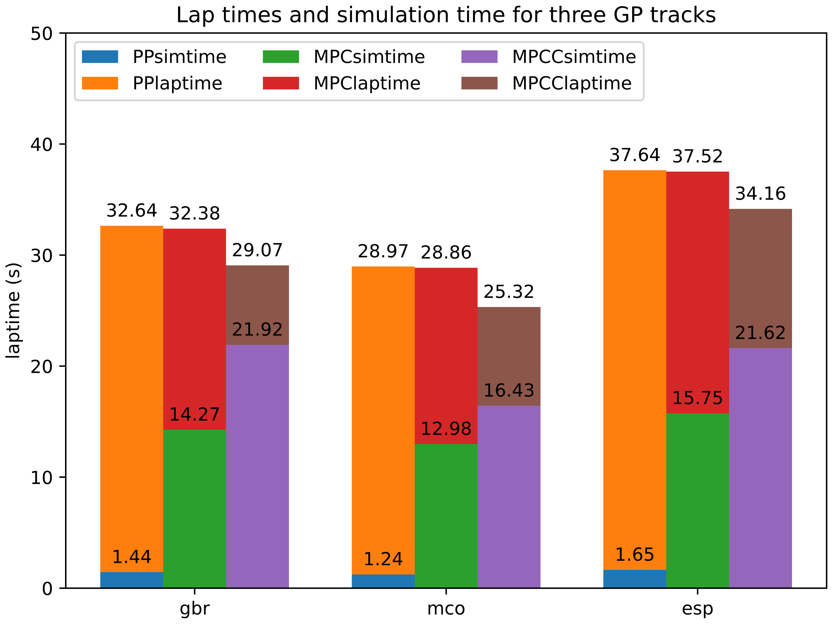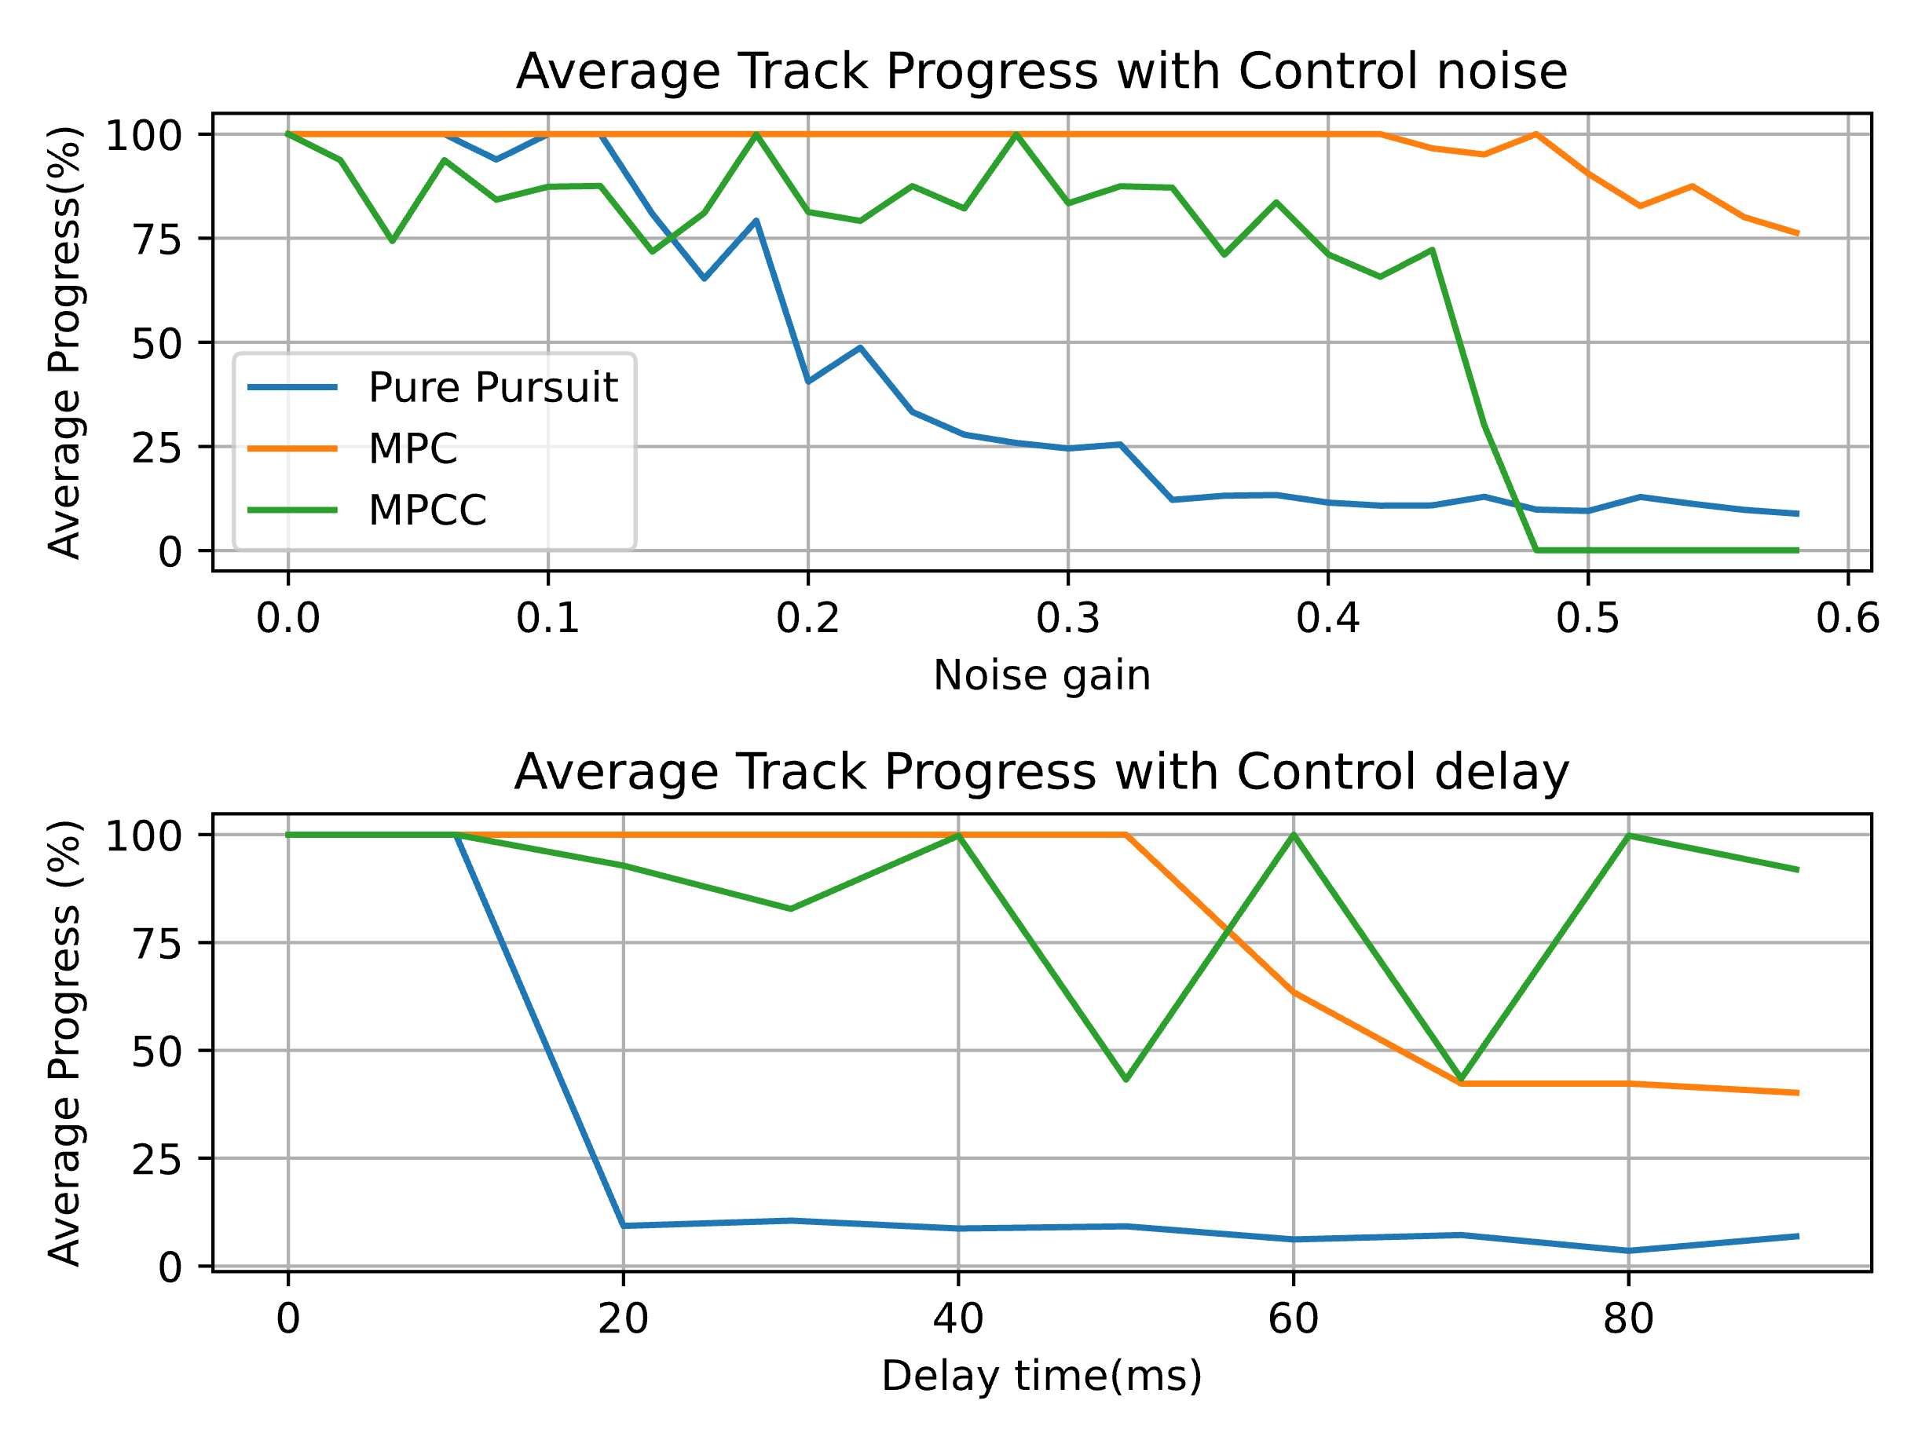

**Figure 1: Track progress with disturbance and lap time and sim time.**

Figure 1 (left) shows the lap time and simulation time with no disturbances, Figure 1 (right) shows initial results of the average progress with some disturbances added. Results show that the Pure Pursuit algorithm is efficient in computation but shows weakness in the presence of disturbances. MPC is robust in both noisy and high delay settings, however, to the detriment of computation time. MPCC is the also robust to noise and delay, but, has a longer computation time. Overall, it is 3 seconds faster than the other algorithms in each track, proving to be the best autonomous racing methods.

**CONCLUSION**

The results show that Pure Pursuit has an extremely efficient computation time. However, it has poor performance in high-speed racing scenarios. MPC is overall the most robust system, making the most track progression without crashing while requiring a relatively low computation time. MPCC was the best autonomous racing strategy as it was able to complete the track 3 second faster than the other two methods while being robust to disturbance.

**REFERENCES**

**[1] Kapsalis, D.** 2021, Design and experimental validation of an LPV Pure Pursuit automatic steering controller, IFAC PapersOnLine, 54-2, pp 63-68.

**[2] Wang, H., Liu, B.** 2019, Path tracking control for autonomous vehicles based on an improved MPC, IEEE Access, Volume 7, pp 161064-161073.

**[3] Lam, D., Manzie, C., Good, M.** 2010, Model Predictive Contouring Control, 49th IEEE Conference on Decision and Control, pp 6137-6142.

**[4] O'Kelly, M., Zheng, H., Karthik, D., Mangharam, R.** 2020, F1tenth: An open-source evaluation environment for continuous control and reinforcement learning, Proceedings of Machine Learning Research, vol 123.